Instruction for Use

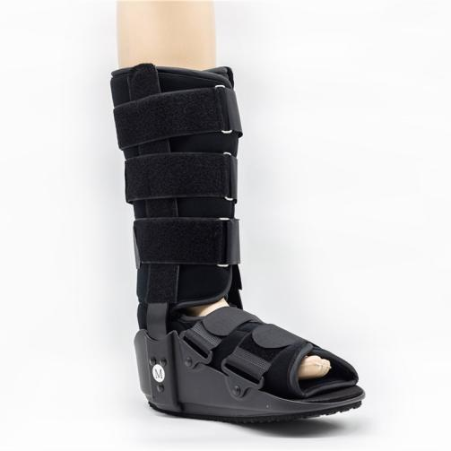

Common Examples of Use

Ankle and foot stability fractures.

Severe ankle ligament sprain.

Used after ankle and foot fractures, reduction or internal fixation surgery.

Postoperative fixation of Achilles tendon repair (adjustable to forefoot weight-bearing position and heel non weight-bearing condition).

Early removal of plaster was used to protect unhealed fractures or tissues.

WARNING:
This product should be given by an treating doctor and applied by a professional. Application should be done with great care to ensure correct fit and efficiency of the brace. For hygiene reasons, it is proposed to be used by a single patient. Recommended product use up to 2 years.

WASHING INSTRUCTIONS:
Check the condition of the product before use. If it is worn off, it needs replacement.
Hand wash with cold water. Use a soft detergent and remove the pads.
Allow to dry on its own. Do not wash it in a washing machine or dry it in a tumble dryer.

